Storing Tabular Data in Azure

1. Azure Storage

It’s a part of IAAS.

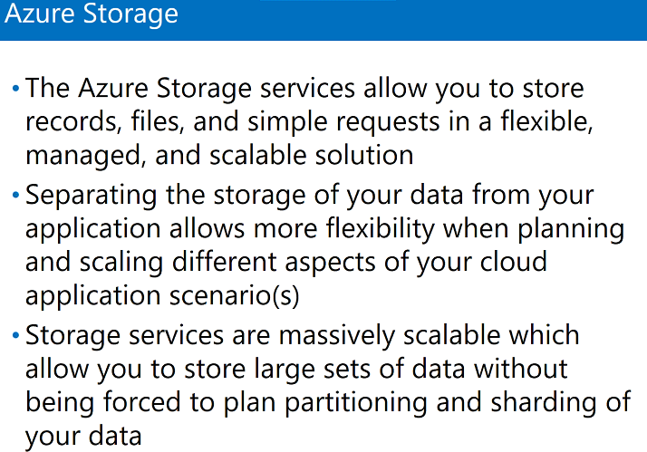

1. Types of Storage

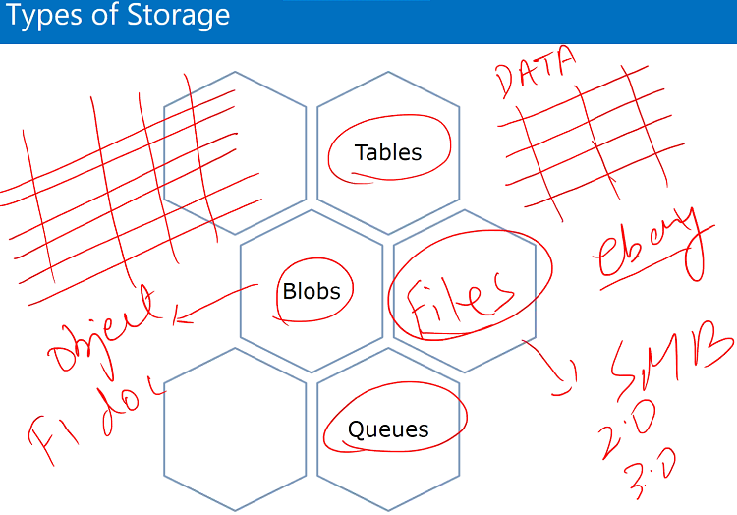

**Table** – it stores data in structural from in rows and column. It don’t have any limit. Can store large amount of data.

**Queues** – to store information in a location that what is going to be processed next. Saving inter application messages in storage.

**Files**- storing SMB small messaging block. Use for migration scenarios.

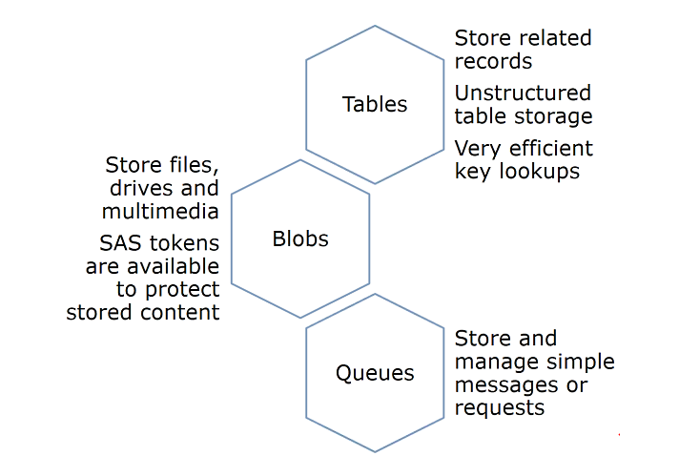

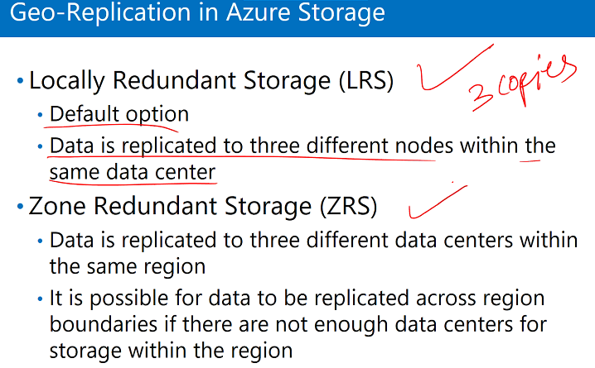

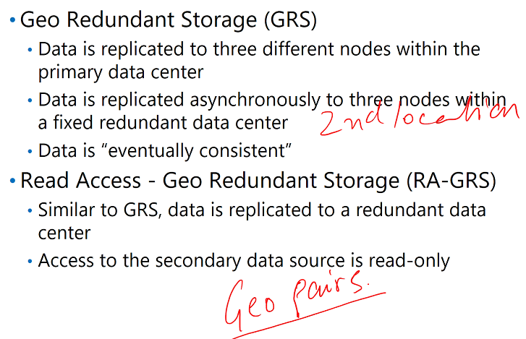

1. Accessing Storage Data

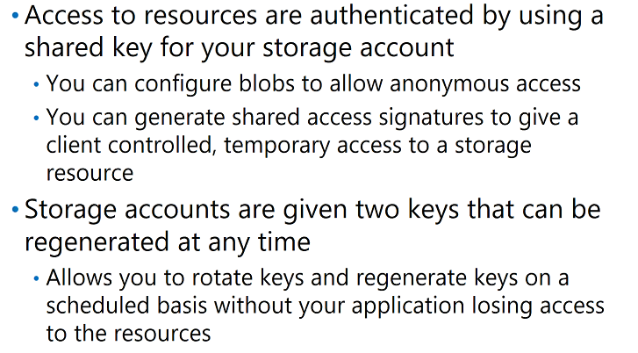

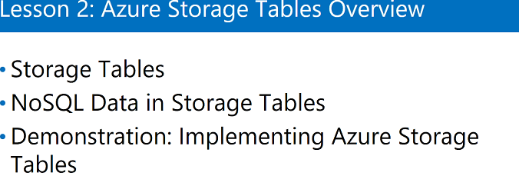

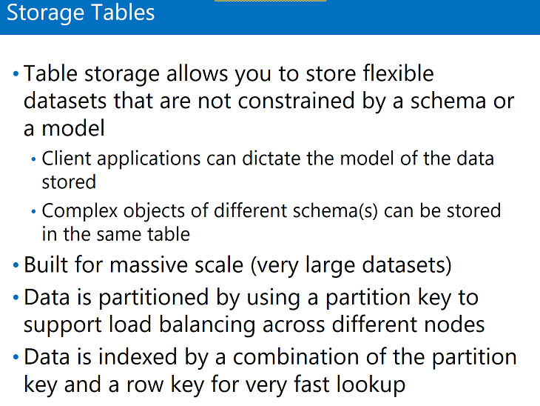

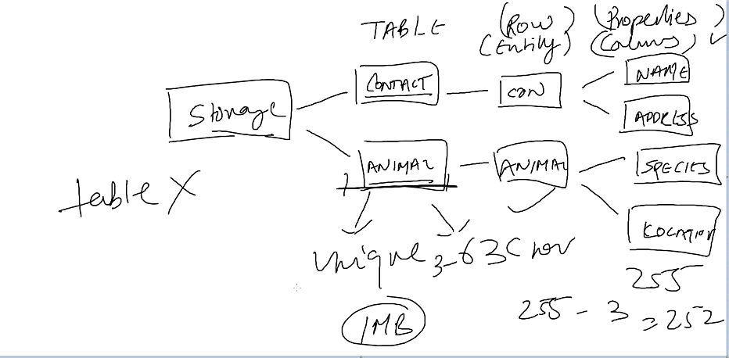

Properties: properties name 255 characters, 3 are reversed which are called system properties.

Table name: 63 characters

Limit of storing data in a particular entity or row: 1 MB

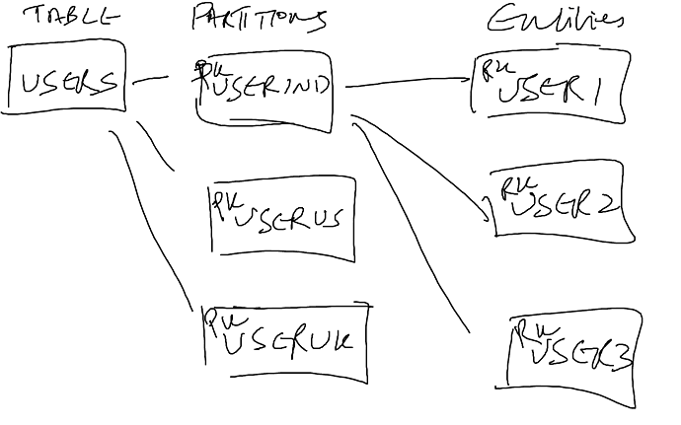

How do we put information in tables?

Developers, who are developing the application are responsible for putting the information and retrieving the information using the partition key and using the row key in table.

Labs: Implement table in Azure using .NET

1. Create a console .net project
2. Add the package : Azure.Storage
3. Add name Space



1. Copy the default connection string and paste in config. File

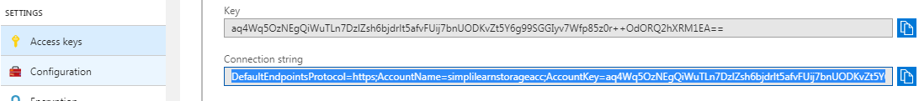

1. Add the connection string

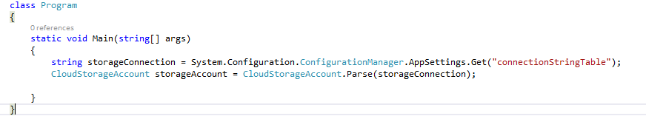

1. Create table if doesn’t exist



1. Insert property in table

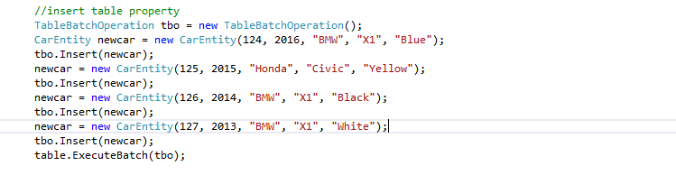

**Cosmo DB**: Enhancement in table storage

**Mongo DB**: no SQL storage.

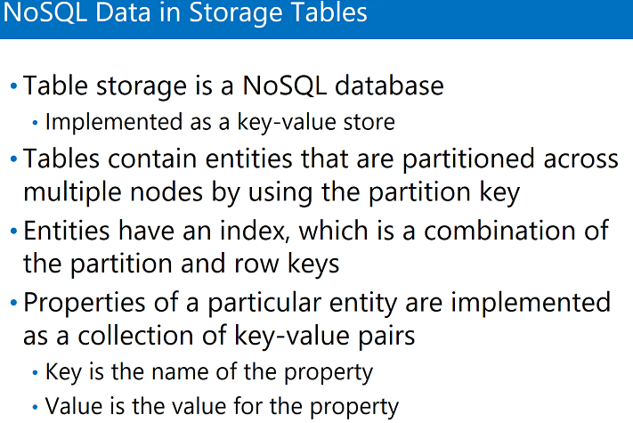

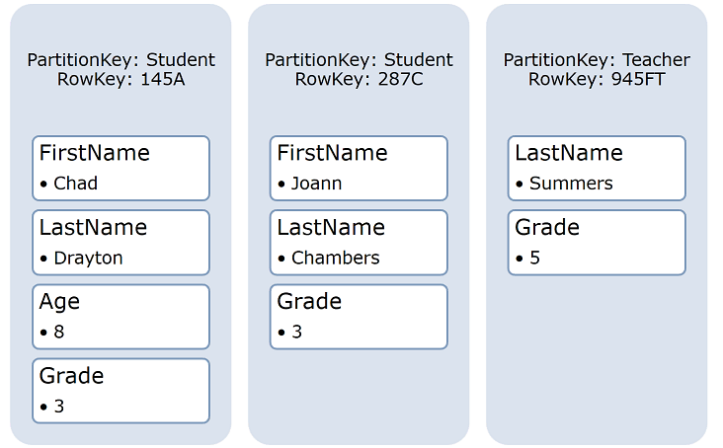

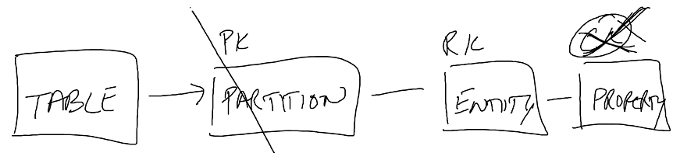

First we define PK then search for RK and find the property.

500 TB limit of table

**CosmoDB:** we can run SQL statements, query the Statement, scale up, and scale down

Designing a Communication Strategy by Using Queues and Service Bus

Azure Storage Queues:

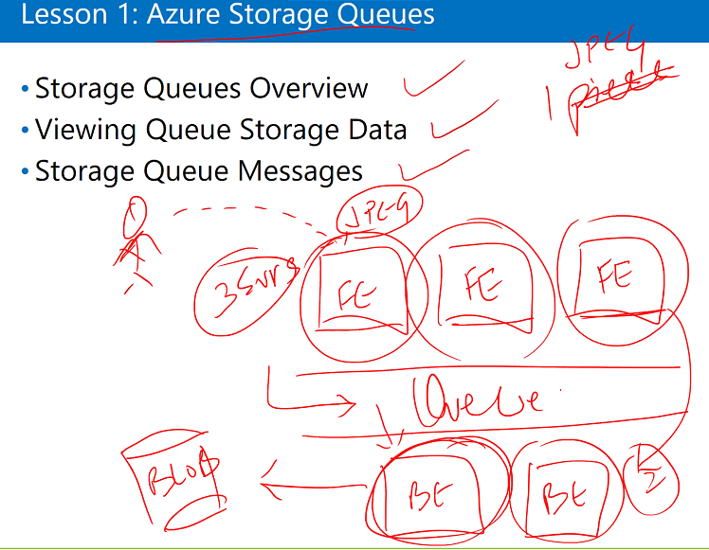

If frontend is doing the backend part also then we don’t need queues.

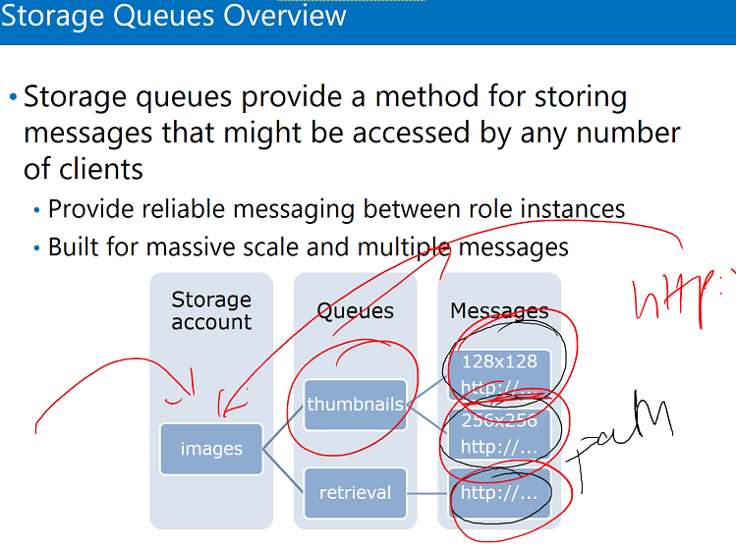

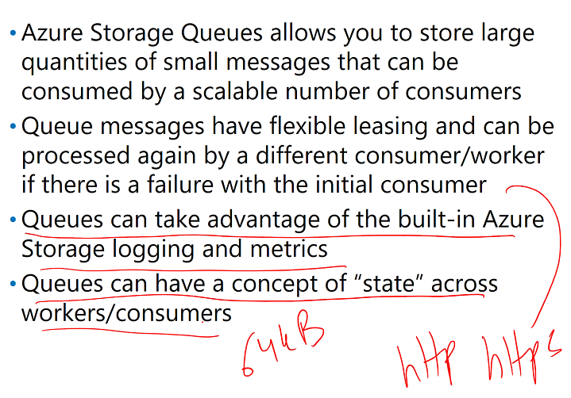

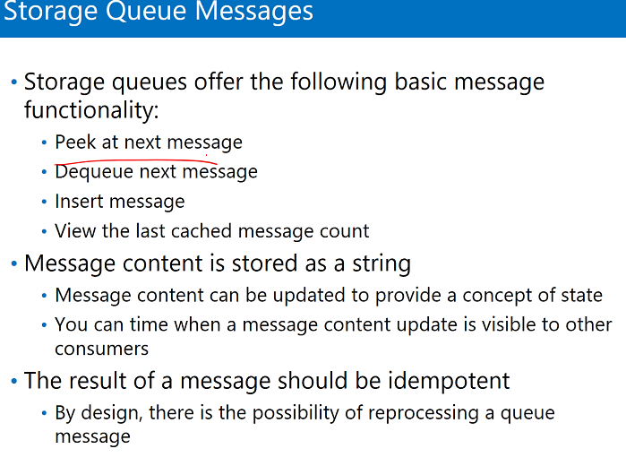

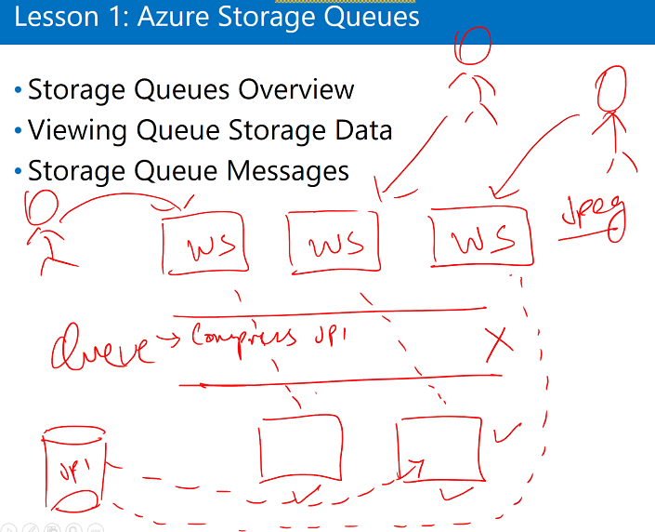

Let we have three front end and two backend server. Let three users send three images to compress. The third image will be stored in database and the message (third image is the next image to be compressed) will be stored in queue.

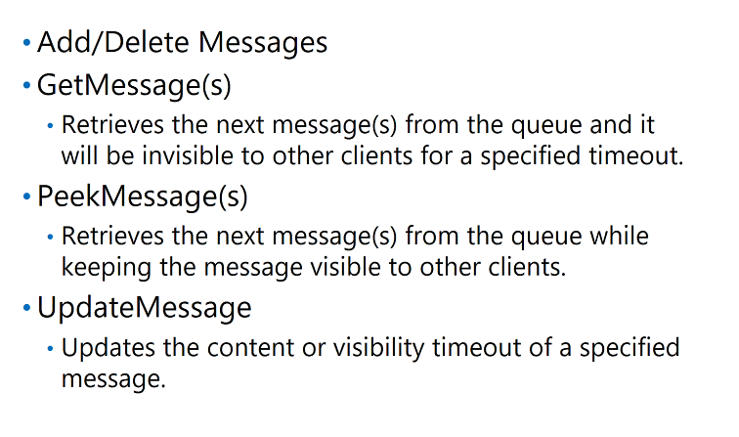

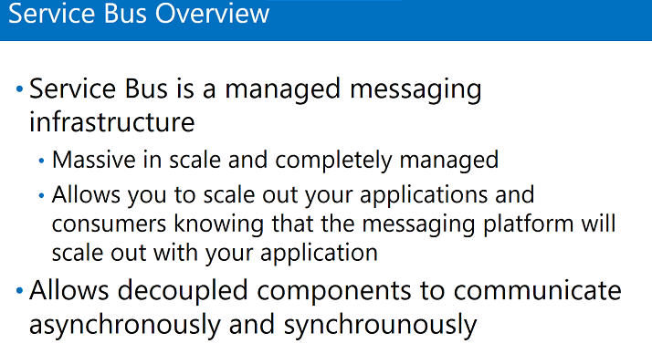

This is the enhancement to queues storage, more reliable, to make communication easier between frontend and backend.

Job is like third party service. Makes sure that messages are delivered. In queues we don’t have middle party but in service bus we have.

Service bus has three major component

1. Queues – one directional communication between frontend and backend, received by single recipient, can’t filter. Store message
2. Topics – we can filter the message, one directional communication, Store message
3. Relays – two way communication, don’t store messages jus pass the messages

Topics

Sender will send the messages but Topics will filter the messages based on the condition which our application puts in it.

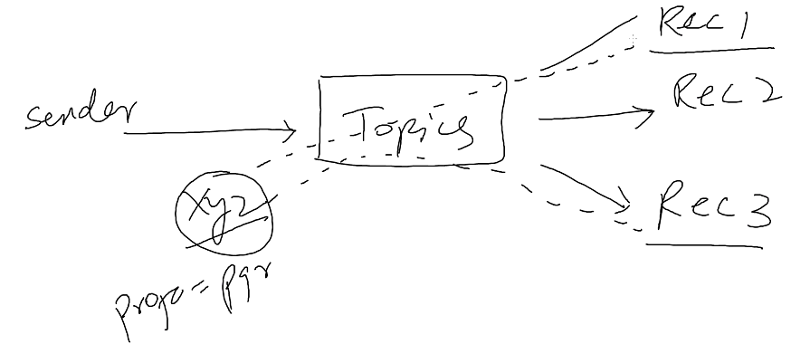

Relays

Sender will send the message and receiver can receive the message, then receiver can act as sender and sender can act as receiver.

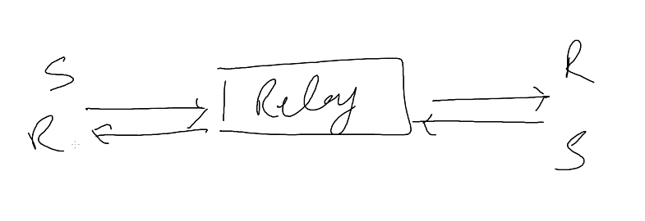

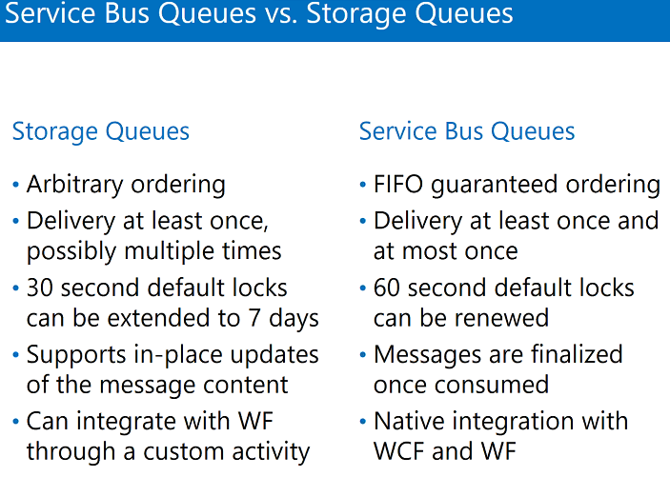

How do we write messages in Service Bus:

1. Select Service Bus (this is also URL based)
2. Create
3. Create queue

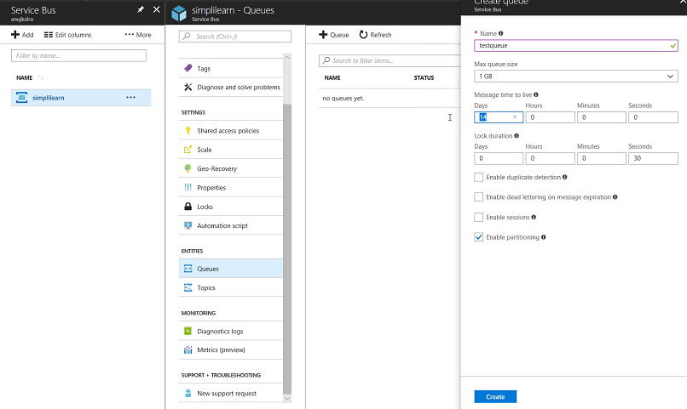

1. Create
2. Shared access policies- create a key- this will be used to control queues.

Used to put information in queues.

1. Now, write the message in this queue(queue is already created in service bus).(put some information in queue)
2. Open VS
3. Create console app project
4. Add package service bus
5. Get shared access signature
6. Use for connection string

It will increase the message count

